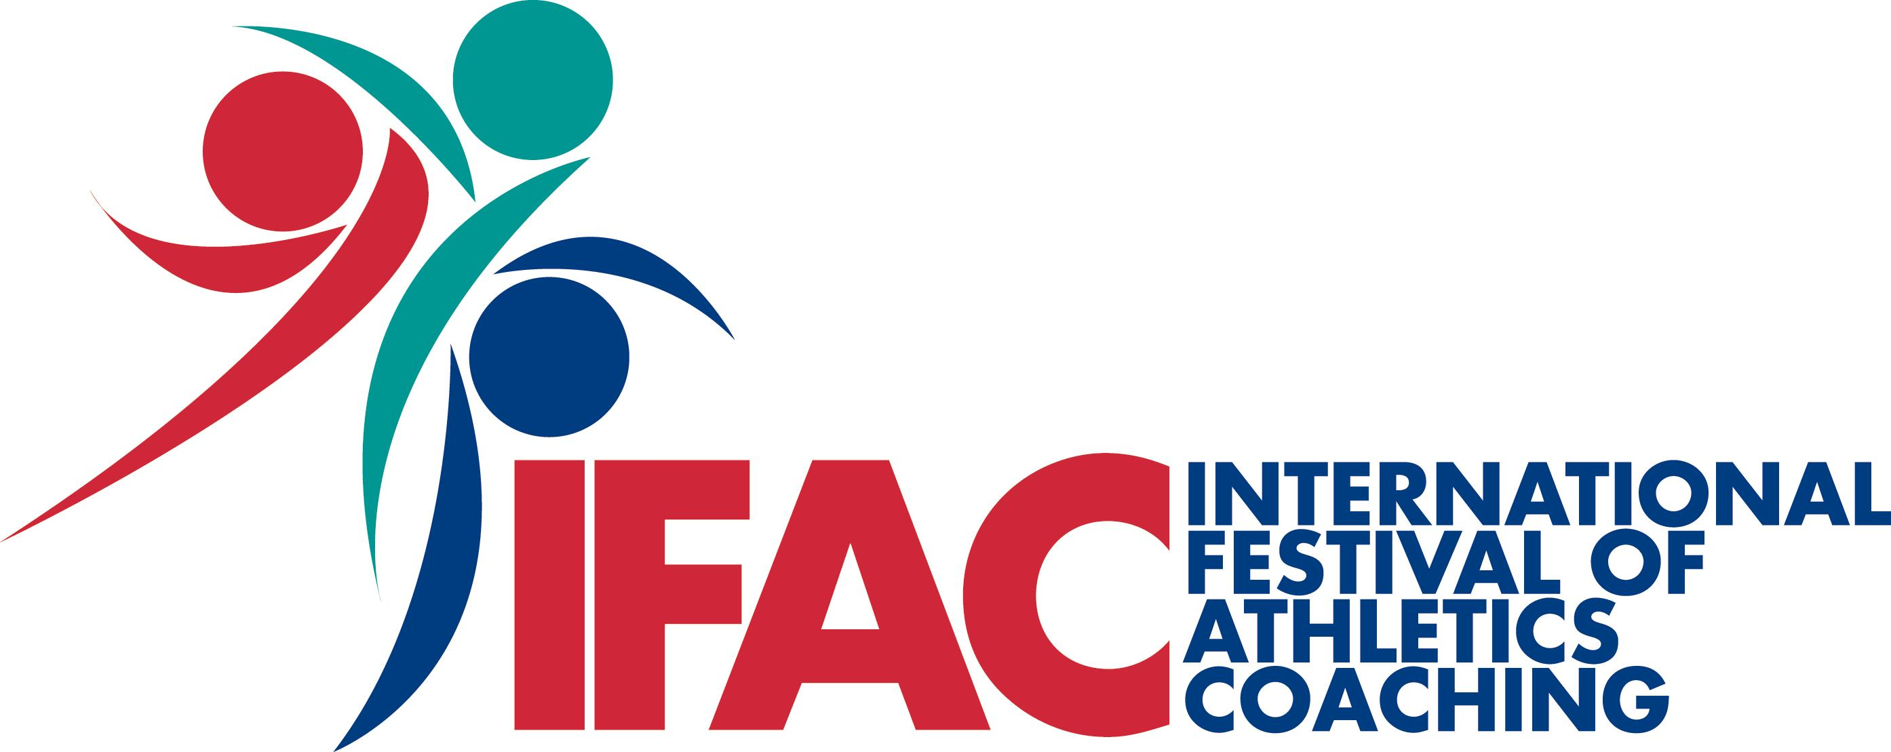

International Festival of Athletics Coaching (IFAC) 2010 Booking form

Delegate Options: (Rates do not include accommodation)

Conference only (Friday to Sunday)

OPTION A - scottishathletics member and UKA licenced coaches - £85
(* Early bird* - if places booked prior to 30 June there will be £5 discount)

OPTION B - Others - £115.00
OPTION C - EACA Member Coaches - £95.00

One day price (Saturday OR Sunday Conference only):

OPTION D - scottishathletics member and UKA licenced coaches - £50.00
OPTION E - Others - £60.00

Delegate Name
Address

Post/Zip Code
Contact Telephone
Email address – must be provided for booking confirmation and for correspondence regarding workshop choices
Club/Organisation
National Federation (must be completed if attending from out with the UK)

Please charge my card for:

OPTION A - £85.00 
OPTION B - £115.00 
OPTION C - £95.00 
OPTION D - £50.00  (Please select one day from Saturday/Sunday)
OPTION E - £60.00 

Payment Details – Please select one:

Cheque (UK only):  Visa:  Switch/Maestro: 
Visa Debit:  Mastercard:  Solo: 

Cheques payable to ‘Scottish Athletics Ltd’

CARD NUMBER:

 
Valid From (Month/Year) / Expires (Month/Year) /
CCV (last 3 digits on signature strip) 

Accommodation Requirements:

Accommodation: Single rooms at £86 and Twin or Double rooms at £96 are available on a bed and breakfast basis (all subject to availability at time of booking).To book your accommodation please contact the hotel direct on 00353 2142 16346 quoting Ref: A25

Please return this booking form to mary.anderson@scottishathletics.org.uk or by post to:

Mary Anderson
IFAC Bookings
Scottish Athletics Ltd
Caledonia House
Redheughs Rigg
South Gyle
Edinburgh
EH12 9DQ

